Lecture 2: Introduction to Nucleic Acids and Lipids

Question 1:

Take a look at the two structures below. (1) Can you identify which base pairs are depicted?
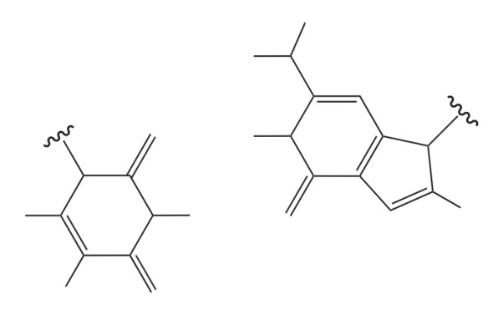
- Can you identify which base pairs are depicted?
- The atom labels are missing in the structure for each atom. Can you label all atoms which correspond to this base pair? If there are hydrogen bonds, please also label them between the base pairs.
- Identify the major and minor grooves of the base pair. Name the interactions along the grooves.
- Is this base pair a standard Watson-Crick pairing?

Question 2:

In the image below you can see a cartoon representation of a complex between DNA and the protein p53. This protein is a well-known tumor suppressor protein that regulates the cell cycle and helps prevent cancer by binding to DNA and activating genes that repair damaged DNA. Many DNA interacting proteins contain cationic domains to bind to DNA.
- Explain why these cationic domains are important for DNA-binding proteins (in terms of electrostatic interactions).
- How do these DNA-binding proteins discriminate between specific DNA sequences? Think about the shape and chemical properties (type of interactions) of the protein and how it relates to specificity.
- DNA-binding proteins can be phosphorylated after translation. Why would the cell phosphorylate these proteins and what does it do to DNA binding?
- Mutations in DNA-binding protein can heavily disrupt their function leading to a disease. Why can a mutation in a DNA-binding protein affect the protein-DNA interaction?
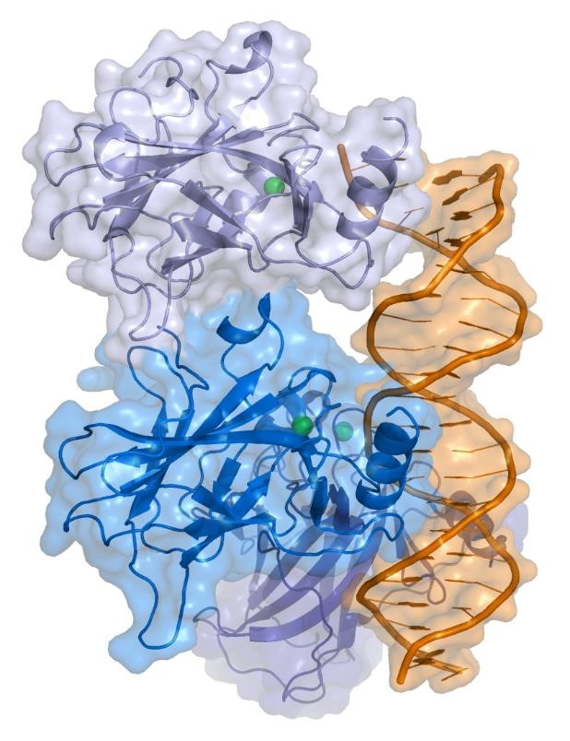

Question 3:

A bacterial DNA polymerase replicates DNA at a rate of approximately 1000 base pairs per second. The polymerase holoenzyme is about 110 Å (angstroms) in length. How many times its own length does the polymerase move forward along the axis of the DNA double helix in 5 seconds? Please show the calculation. We can assume that the DNA remains stationary, and we also ignore the rotational movement of the polymerase around the DNA.
Question 4:

Non-canonical base-pairing occurs when two nucleotides form hydrogen bonds in a manner distinct from the patterns defined by Watson and Creek. They are particularly common in RNA due to additional flexibility and lack of complementary strands (in most cases). Some examples include Hoogsteen and Wobble pairing.
- In the 6 examples listed below, identify the bases comprising each pair and assign whether they assemble in a canonical (i.e., Watson-Creek) or non-canonical manner?
- What would be the effect of non-canocical base-pairing on the phosphodiester backbone of the poly-nucleotide chain? How would it impact helical assembly? (hint: look at the location of the ribose “R” group)?
- In terms of hydrogen bond count, how do the interactions compare between non-canonical base pairs and the standard A:T/G:C pairs? Which hydrogen bonding network is stronger and why?

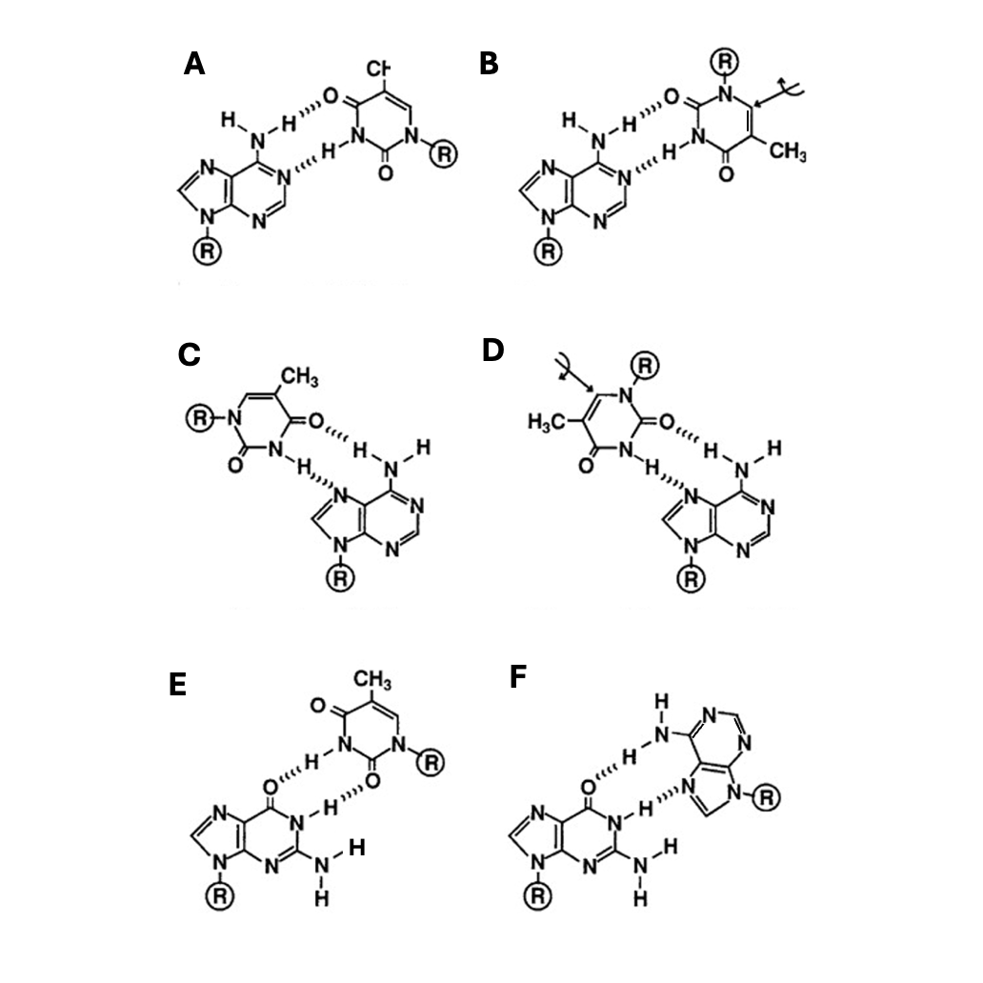

Question 5:

Lipid bilayers forming between two water phases have the following important property: they produce bi-dimensional sheets where their edges seal to form liposomes.
a. What lipid-specific properties account for this behaviour?
b. What is the consequence of this property on biological membranes?

Question 6:
The melting points of a series of 18-carbon fatty acids are: stearic acid, 69.6 C; oleic acid, 13.4 C; linoleic acid, -5 C; and linolenic acid - 11C.
a. What structural aspect of these 18-carbon fatty acids can be correlated with the melting point?
b. List all possible triacylglycerols that can be constructed from glycerol, palmitic acid, and oleic acid. Rank them in order of increasing melting point
c. Branched-chain fatty acids are found in some bacterial membrane lipids. Would their presence increase or decrease the fluidity of the membrane (that is, give them a lower or higher melting point)? Why?

Question 7:
Examine the membrane lipid pictured below and answer the following questions.
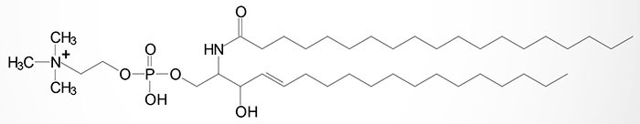
a. Is this lipid classified as a phospholipid or a glycolipid? How can you tell?
b. Is this lipid considered a sphingolipid or a glycerophospholipid? How can you tell?
c. What fatty acid chains are used in this lipid? Are they saturated or unsaturated? What kind of bond links the fatty acids to the headgroup?

Question 8:
A mixture composed of the lipids below is placed on a silica column and eluted with increasingly polar solvents. They will be released from the column based on the relative hydrophobicity (the most hydrophobic lipid elutes first and the least hydrophobic last).
The mix is constituted by:
- Palmitic acid,
- Cholesterol-palmitate,
- Cholesterol,
- Phosphatidylcholine
- Triglyceride.
(Please look up the chemical structures of these molecules online or in lecture slides)
In which order are these lipids eluted from the column (explain the rationale)?

Question 9:
Some archaea that live in extreme environmental conditions such as high temperature, low pH and high ionic strength have membrane lipids containing long-chain (32 carbon atoms) branched hydrocarbons (i.e., phytanol group) linked at both ends to glycerol.
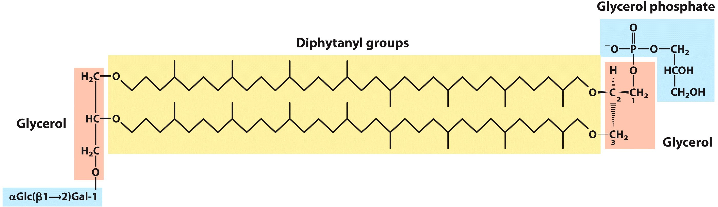
These lipids are approximately 2 times longer compared to “normal” glycerophospholipids which allows them to span through the entire membrane bilayer.

- How are these lipids helping archaea adjust to the harsh environmental conditions in terms of resistance to thermal, mechanical and chemical stresses?
- What would be the consequences of having the membrane completely composed of diphytanyl lipids? How would it affect membrane permeability?

